LAB-2 Report

1. Firstly, i have implemented a mobile web cliebt application using html, javascript and css. Following is the screenshot of it.

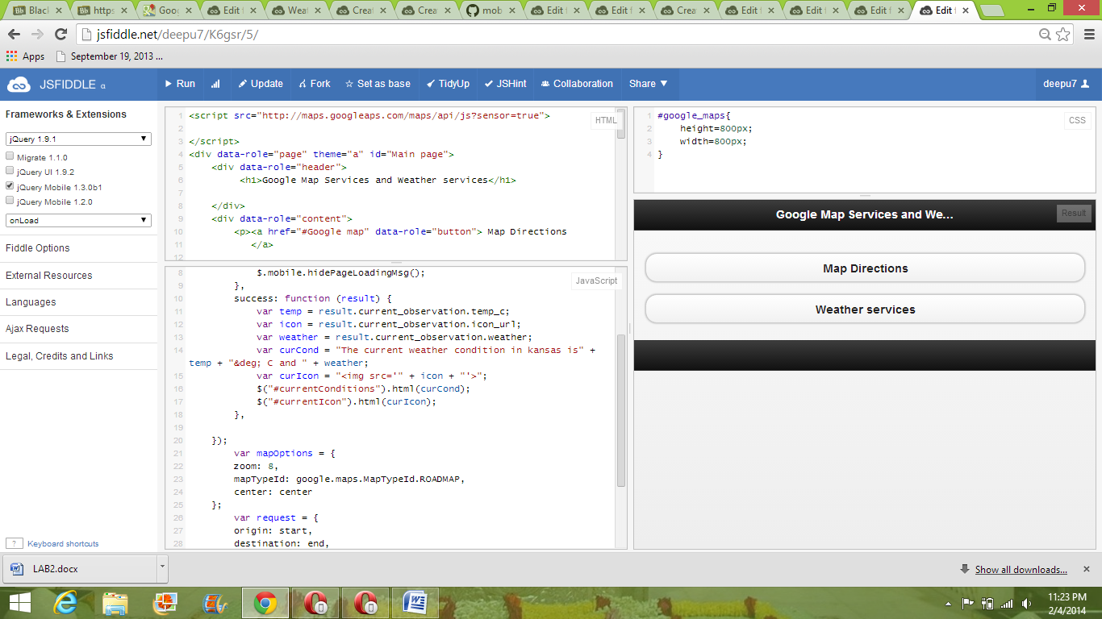

2. This is screenshot of the page that appears when we click Weather Services

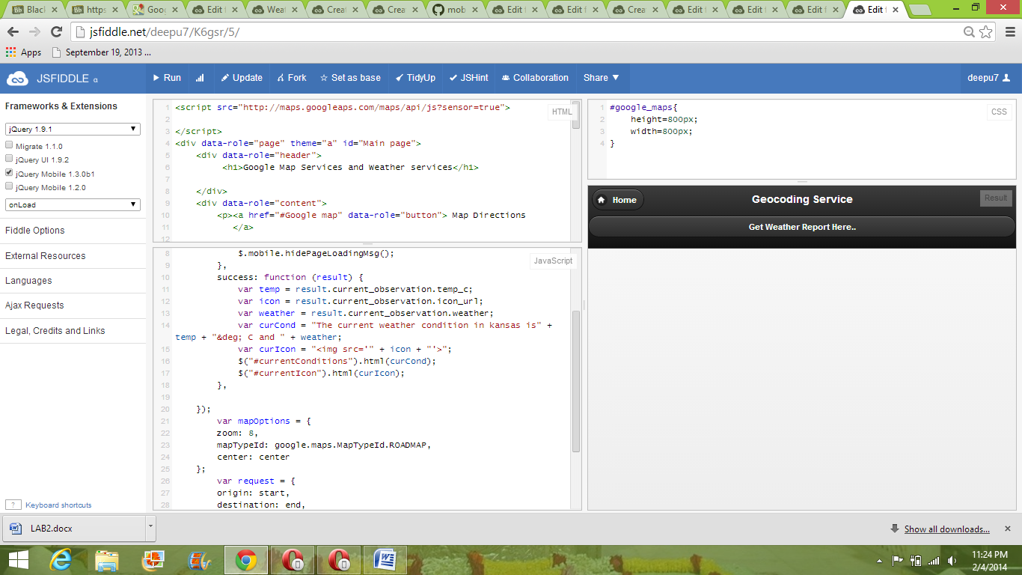

3. When we click Get the weather report here we get the following screenshot.

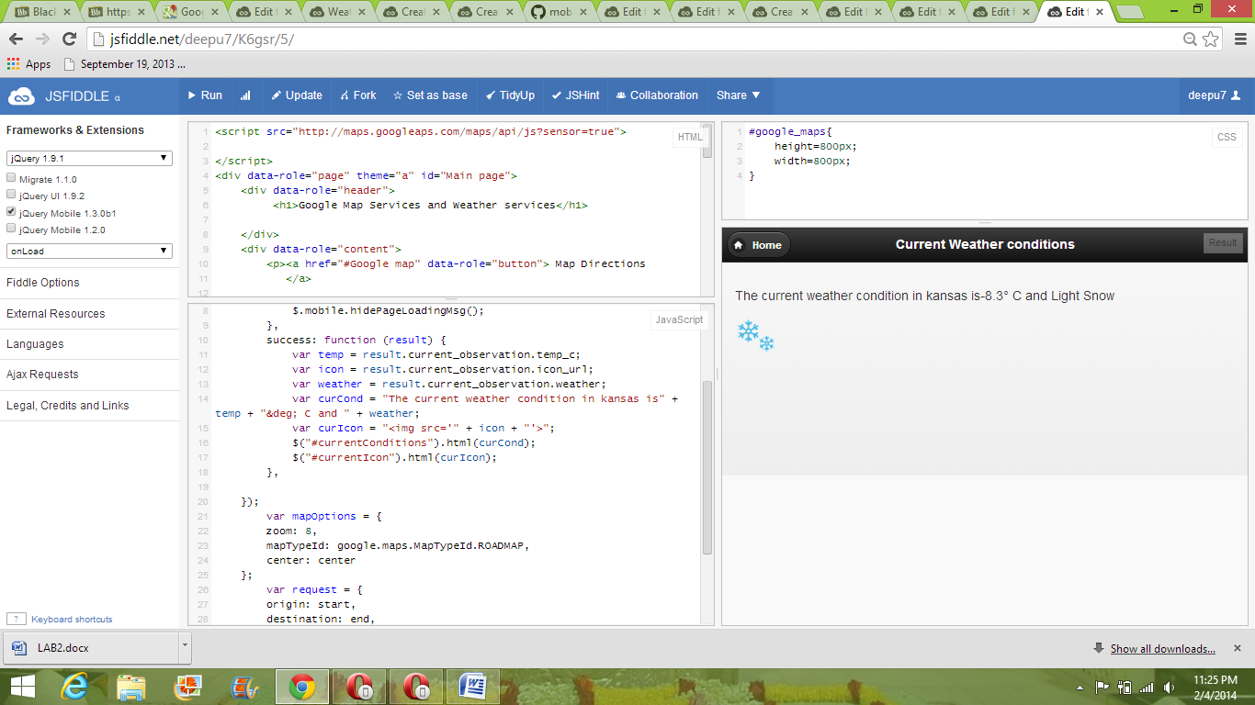

4. We get the following screenshot when we click map directions.

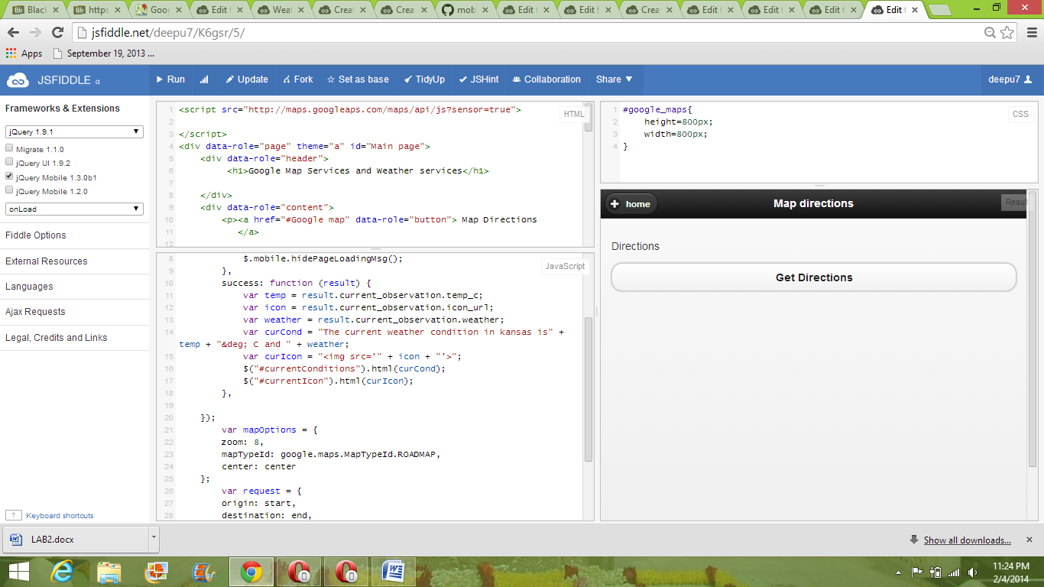

5.These are the screenshots generated by using opera mobile emmulator.